**Practical 24**

1. Write a Program to turn on, turn off, get visible, list visible and turn off Bluetooth with the help of GUI.

Xml Code :

<?xml version="1.0" encoding="utf-8"?>

<LinearLayout xmlns:android="http://schemas.android.com/apk/res/android"

android:layout_width="match_parent"

android:layout_height="match_parent"

android:orientation="vertical"

>

<TextView

android:layout_width="wrap_content"

android:layout_height="wrap_content"

android:text="BLUETOOTH"

android:textStyle="bold"

android:layout_marginTop="15dp"

android:textColor="@color/black"

android:textSize="35sp"

android:fontFamily="sans-serif-smallcaps"

android:layout_gravity="center"

android:gravity="center"

/>

<LinearLayout

android:layout_width="match_parent"

android:layout_height="wrap_content"

android:gravity="center"

android:layout_marginVertical="15dp"

android:orientation="horizontal">

<Button

android:id="@+id/b1"

android:layout_width="wrap_content"

android:layout_height="wrap_content"

android:onClick="geton"

android:text="ON"

android:layout_marginHorizontal="2dp"

android:textColor="@color/white"

android:backgroundTint="@color/black"/>

<Button

android:id="@+id/b2"

android:layout_width="wrap_content"

android:layout_height="wrap_content"

android:onClick="getoff"

android:text="OFF"

android:layout_marginHorizontal="2dp"

android:textColor="@color/white"

android:backgroundTint="@color/black"/>

<Button

android:id="@+id/b3"

android:layout_width="wrap_content"

android:layout_height="wrap_content"

android:onClick="getvisible"

android:text="VISIBLE"

android:layout_marginHorizontal="2dp"

android:textColor="@color/white"

android:backgroundTint="@color/black"/>

<Button

android:id="@+id/b4"

android:layout_width="wrap_content"

android:layout_height="wrap_content"

android:onClick="getlist"

android:text="LIST"

android:layout_marginHorizontal="2dp"

android:textColor="@color/white"

android:backgroundTint="@color/black"/>

</LinearLayout>

<ListView

android:layout_width="386dp"

android:layout_height="505dp"

android:id="@+id/l1"

android:layout_marginTop="30dp"

android:layout_gravity="center"

/>

</LinearLayout>

Java Code :

package com.example.sensor;

package com.example.bluetooth;

import androidx.appcompat.app.AppCompatActivity;

import androidx.core.app.ActivityCompat;

import android.Manifest;

import android.bluetooth.BluetoothAdapter;

import android.bluetooth.BluetoothDevice;

import android.content.Intent;

import android.content.pm.PackageManager;

import android.os.Bundle;

import android.view.View;

import android.widget.ArrayAdapter;

import android.widget.Button;

import android.widget.ListView;

import android.widget.Toast;

import java.util.ArrayList;

import java.util.Set;

public class MainActivity extends AppCompatActivity {

Button b1,b2,b3,b4;

private BluetoothAdapter BA;

ListView l1;

private Set<BluetoothDevice> pairedDevices;

@Override

protected void onCreate(Bundle savedInstanceState) {

super.onCreate(savedInstanceState);

setContentView(R.layout.activity_main);

b1 = findViewById(R.id.b1);

b2 = findViewById(R.id.b2);

b3 = findViewById(R.id.b3);

b4 = findViewById(R.id.b4);

BA = BluetoothAdapter.getDefaultAdapter();

l1 = (ListView) findViewById(R.id.l1);

b1.setOnClickListener(new View.OnClickListener() {

@Override

public void onClick(View v) {

if (!BA.isEnabled()) {

Intent turnOn = new Intent(BluetoothAdapter.ACTION_REQUEST_ENABLE);

if (ActivityCompat.checkSelfPermission(getApplicationContext(), Manifest.permission.BLUETOOTH_CONNECT) != PackageManager.PERMISSION_GRANTED) {

startActivityForResult(turnOn, 0);

Toast.makeText(getApplicationContext(), "Bluetooth Turned On", Toast.LENGTH_LONG).show();

}

} else {

Toast.makeText(getApplicationContext(), "Bluetooth Already On", Toast.LENGTH_LONG).show();

}

}

});

b2.setOnClickListener(new View.OnClickListener() {

@Override

public void onClick(View v) {

if (ActivityCompat.checkSelfPermission(getApplicationContext(), Manifest.permission.BLUETOOTH_CONNECT) != PackageManager.PERMISSION_GRANTED) {

BA.disable();

Toast.makeText(getApplicationContext(), "Bluetooth Turned Off", Toast.LENGTH_LONG).show();

}

}

});

b3.setOnClickListener(new View.OnClickListener() {

@Override

public void onClick(View v) {

Intent get = new Intent(BluetoothAdapter.ACTION_REQUEST_DISCOVERABLE);

if (ActivityCompat.checkSelfPermission(getApplicationContext(), Manifest.permission.BLUETOOTH_ADVERTISE) != PackageManager.PERMISSION_GRANTED) {

startActivityForResult(get, 0);

}

}

});

b4.setOnClickListener(new View.OnClickListener() {

@Override

public void onClick(View v) {

if (ActivityCompat.checkSelfPermission(getApplicationContext(), Manifest.permission.BLUETOOTH_CONNECT) != PackageManager.PERMISSION_GRANTED) {

pairedDevices = BA.getBondedDevices();

ArrayList list=new ArrayList();

for(BluetoothDevice bt:pairedDevices){

list.add(bt.getName());

}

Toast.makeText(getApplicationContext(),"Showing Paired Devices",Toast.LENGTH_LONG).show();

ArrayAdapter adpt=new ArrayAdapter(MainActivity.this,android.R.layout.simple_list_item_1,list);

l1.setAdapter(adpt);

}

}

});

}

}

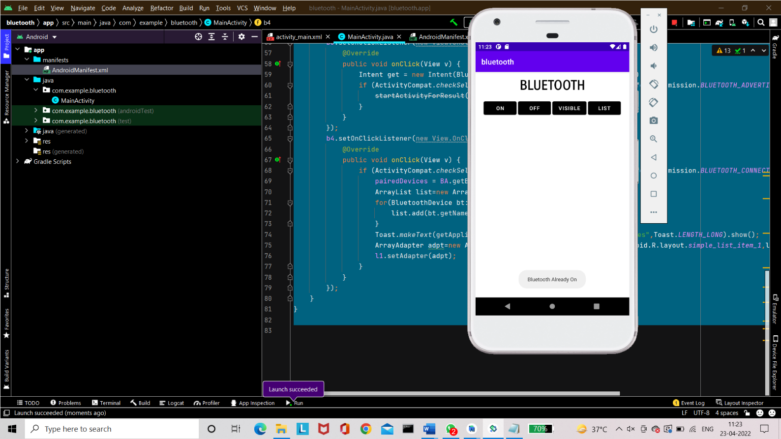Output:

